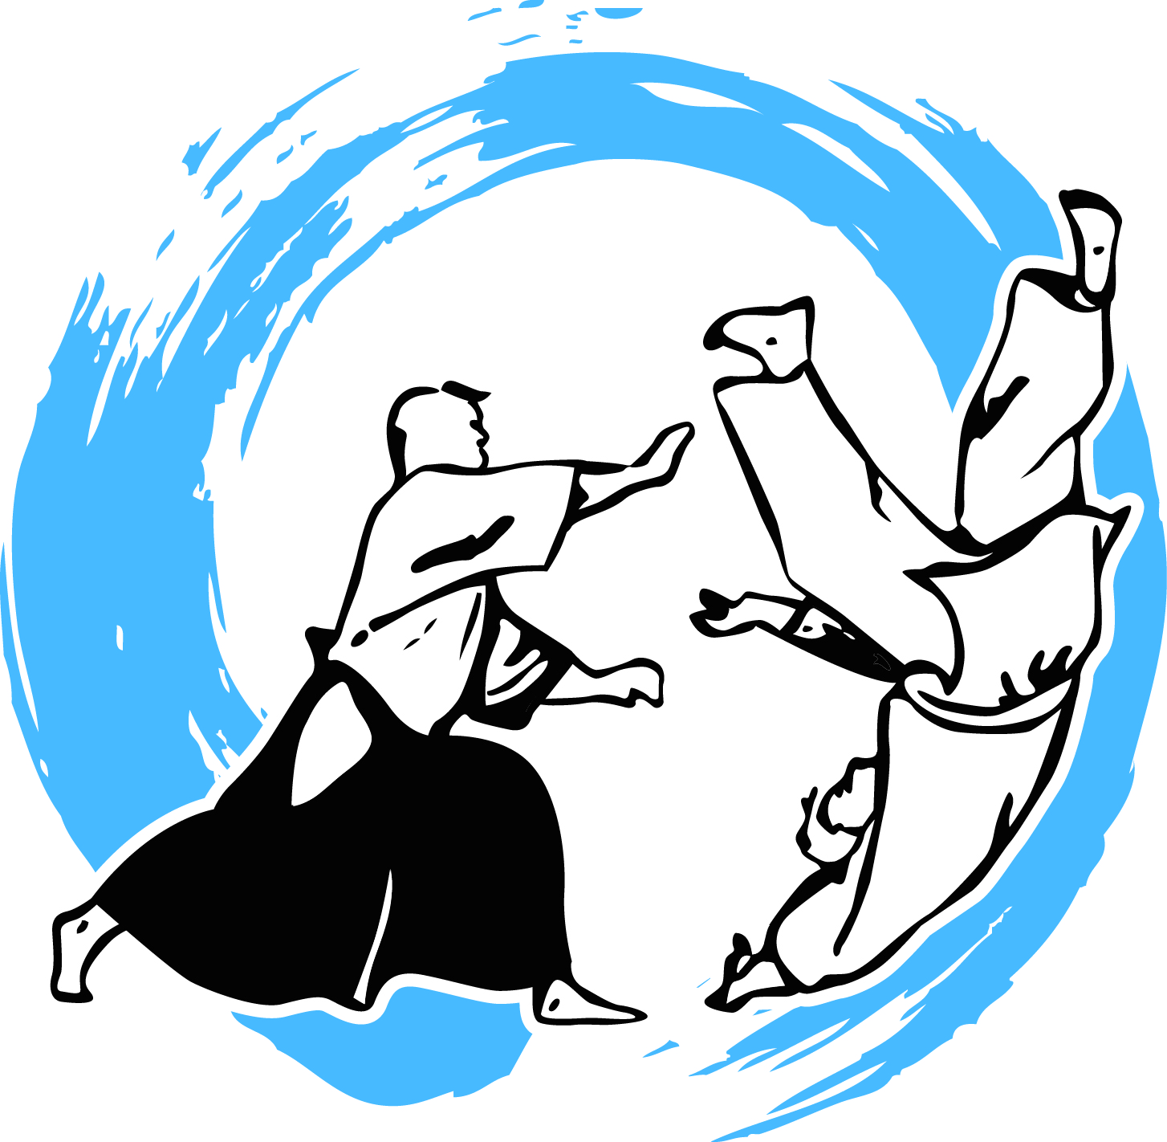
BUSHINKAN

Spirit of Budo

Student Code of Conduct
The Head Dojo Instructor/Instructor reserves the right to direct students to cease training and leave the mat and/or premises.
The Head Dojo Instructor/Instructor reserves the right to accept new students for training or to decline to accept a student.
Successful risk management is best achieved when all students adopt a spirit of responsibility in regard to safety issues. Students should be aware of and agree to adhere to, the following measures:

Prior to Training
- Be aware of the dojo's safety policies before undertaking training. Advice is available from Instructors.
- Notify the Head Dojo Instructor/Instructor of any pre-existing medical condition or disability prior to training. For serious conditions a medical clearance must be obtained.
- After serious injury or illness, students should not return to physical training until the student has fully recovered. If there is any doubt, a medical clearance must be obtained.
- Students must not participate if they have injuries or conditions such as serious cuts or abrasions, rashes, boils or any other contagious condition. Minor abrasions and cuts must be adequately dressed and covered prior to training.
- Remove jewellery, watches and other ornaments prior to training, which may cause injury.
- Long hair must be secured.
- Fingernails and toenails must be smooth and short.
- Wear a training gi or other appropriate clothing and ensure that it is in good repair.
- Ensure that weapons are in good repair and stored in appropriate manner when not in use.
- Cleanliness of both clothing and person is essential.
- Never train under the influence of drugs or alcohol.

During Training
- At all times, obey the instructions of the Instructor including the direction to cease training.
- Students may opt to decline to participate in any activity they feel uncomfortable with.
- Students should train at a level they feel comfortable with. Always attempt a technique/activity at the basic level before proceeding to a more advanced level.
- Partners should train at the level of the least experienced partner.
- Competency at rolling and break falling is developed over a long period of time. Partners should agree prior to training whether they are prepared to take a fall (ukemi). Proceed slowly.
- Take care to avoid collisions on the mat by being aware of the other students training on the mat.
- Train only in the specific technique demonstrated by the Instructor.
- Freestyle training must be supervised by an Instructor.
- Report all accidents to the Instructor immediately. Exercise universal precautions in regard to biological hazards.
- Notify the Instructor if any medical condition becomes apparent during training that may affect safety.
- Students should pace themselves according to their level of fitness and competency.
- Students should avoid dehydration and over-exertion. Students must train in a spirit of non-dissension. Should issues arise on or off the mat students are expected to discuss it with each other to resolve it harmoniously, then, if required, to bring the issue to the attention of the Head Dojo Instructor for mediation and/or resolution.

Student Signature: | Instructor’s Signature:
Name: | Name:
Date: / / | Date: / /

